1. Overview
In the usage scenarios of lithium batteries, low-temperature scenarios are essential, but the performance degradation of batteries is significant in low-temperature environments.
Mainly manifested in the following aspects:
◆
Reduce capacity: The capacity of lithium-ion batteries will decrease in low-temperature environments, as low temperatures can cause internal chemistry in the battery
The reaction rate slows down, reducing the energy output of the battery.
◆
Reduce power: In low-temperature environments, the internal conductivity of the battery decreases, the internal resistance of the battery increases, and the output power of the battery is reduced
Reduce, resulting in a decrease in vehicle acceleration performance.
◆
Extending charging time: Low temperatures can slow down the internal chemical reaction rate of the battery, increase the internal resistance of the battery, and cause
The extended charging time accelerates the aging of the battery.
◆
Reduced lifespan: Prolonged use in low-temperature environments can lead to changes in the internal structure of the battery, such as electrode materials
The detachment and passivation of materials lead to a shortened battery life.
Therefore, the battery heating function has emerged, which can effectively improve the performance degradation of lithium batteries caused by low temperatures.
2. Functional characteristics
◆
This function is achieved by detecting the battery temperature, combined with low-temperature charging protection/recovery temperature, and charger status to achieve electricity
Pool heating control function.
◆
Maximum heating current: 3A
◆
Recommended current: 2.5A @ standard battery voltage
◆
Maximum heating voltage: 100V
3. Control logic
The heating activation condition is to enable the charging and heating function by satisfying both condition 1 and condition 2 or condition 3.
◆
Condition 1: The battery temperature is lower than the low-temperature protection temperature for charging;
◆
Condition 2: Turn on heating through the APP, do not detect the charger status, and heat up when the low temperature condition is reached, which will consume
Battery level;
◆
Condition 3, charger insertion detected. This function is related to the protection board hardware and charger, so please place an order first
Confirm the technical status.
4. Heating film selection
◆
The first step is to clarify the maximum total voltage of the battery, for example, the maximum total voltage of 20 series of lithium iron batteries is 20 * 3.6=72V, and the maximum total voltage of 24 series of lithium iron batteries is
The total pressure is 24 * 3.6=86.4V.
◆
Step 2, determine the resistance value of the heating film. The resistance value is equal to the maximum total voltage ÷ 3A, for example: 72V ÷ 3A=24 Ω, combined with
Choose heating film specifications on the market that are close to the resistance value. The heating film specification is 72V/24 Ω/216W.
- Definition of heating interface and cable image

5.1 interface definition
Heating port  Optional function | Pin | Signal | Description | Wiring
Heating port  Optional function | 1~5 | HT- | Positive pole | Connect either end of the heating film, and connect the other end of the heating film to the main positive terminal
Heating port  Optional function | 6 | HT+ | Charging + | To be used with a charger with a 12V auxiliary power supply, separate  Connect the positive and negative terminals of the auxiliary power supply. If there is no auxiliary power supply, do not connect it
Heating port  Optional function | 7 | CD- | Charging -
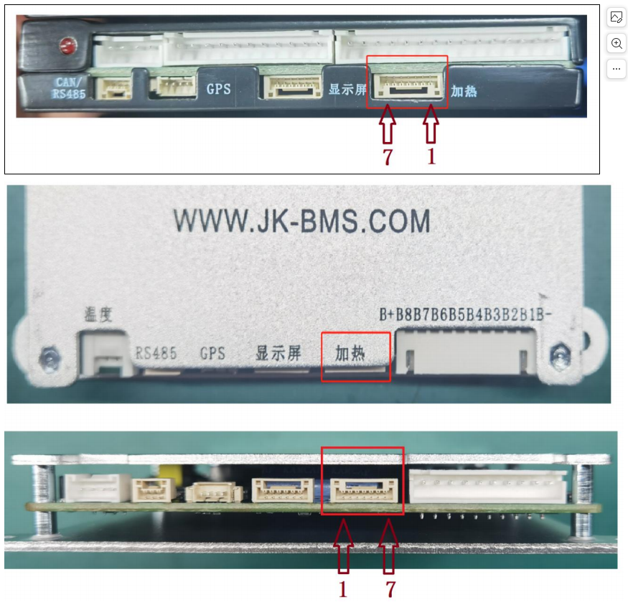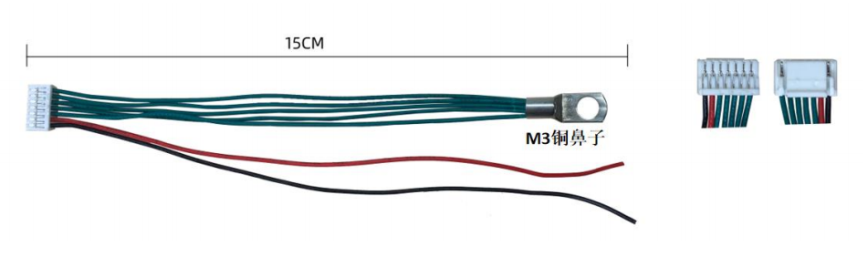
In order to prevent safety risks caused by battery overheating due to circuit losses in the heating switch of the protective board. Suggest heating
The temperature control switch is connected in series in the circuit as a secondary protection to ensure zero risk. Suggest choosing 45~65 ℃ normally closed temperature control
Switch, when the temperature exceeds the nominal temperature, the switch will automatically disconnect to prevent further heating.
